

Evaluating for the Better Future: Inclusive and Ethical Practices of Evaluation

Conference Report

Date: 3 June 2025
Venue: Georgian Institute of Public Affairs, Frontline Georgia Club
Organized by: Monitoring, Evaluation, and Learning Professionals Association (MELPA)

Table of Contents
1. Executive Summary 3
2. Background 3
3. Objectives of the Conference 4
4. Conference Proceedings 4
Opening Remarks 4
Session 1 - SDG Country Reports – New Methodologies and Opportunities for Georgia 5
Session 2 – Human Rights Approaches to Data – learning on inclusive data practices 7
Session 3 - Ethics in Evaluation – way forward for Georgia 8
Session 4 – Evaluating social justice – participatory MEL in practice 9
Session 5 - Challenges and opportunities for professionalization of Evaluation in Georgia 10
Action Planning & Closing Remarks 12
5. Annexes 13
Annex I - Conference Ageda 13
Annex II - from participants 14
Annex III – Pictures 17

1. Executive Summary
The Glocal Evaluation Week 2025 event in Georgia, organized by the Monitoring, Evaluation, and Learning Professionals Association (MELPA), was held on 3 June 2025 at the Frontline Georgia Club, Georgian Institute of Public Affairs (GIPA) in Tbilisi. Designed as a hybrid conference, it brought together over 80 participants in person and online, creating a space for exchange across borders, sectors, and disciplines.
The event gathered evaluation experts, practitioners, and scholars from Finland, Germany, Poland, Jordan, and Georgia. Conference featured speakers from MELPA, UNDP, the German Institute for Development Evaluation (DEval), the International Organization for Cooperation in Evaluation (IOCE), and the Polish Evaluation Society (PES). Participants included national civil society leaders, government officials, academic institutions, donor representatives, and independent consultants, reflecting the rich diversity of the evaluation ecosystem.
The conference was structured around five thematic sessions focused on urgent and interconnected priorities:
Session 1 - SDG Country Reports – New Methodologies and Opportunities for Georgia
Session 2 – Human Rights Approaches to Data – learning on inclusive data practices
Session 3 - Ethics in Evaluation – way forward for Georgia
Session 4 – Evaluating social justice – participatory MEL in practice
Session 5 - Challenges and opportunities for professionalization of Evaluation in Georgia
Through expert presentations and open discussion, the event highlighted both global lessons and local realities, emphasizing the need to strengthen evaluation capacity, embed inclusive and rights-based approaches, and address persistent gaps in political will, institutional culture, and resource availability.
A recurring message throughout the day was that evaluation in Georgia remains fragmented and largely donor-driven, with limited uptake of recommendations by public institutions. Additionally, participants pointed to the absence of shared standards, Georgian-language materials, and sustainable training pathways as barriers to professional growth.
A key outcome of the event was MELPA’s decision to launch a series of working groups aimed at co-developing Georgian-language resources, advancing shared professional standards, and fostering an evaluation culture that supports evidence-based policymaking, learning, and accountability.
As the global community approaches the 2030 Agenda deadline, this event reaffirmed the critical role of evaluation in advancing democratic values, inclusion, and sustainable development. The Glocal Evaluation Week – Georgia Edition successfully created momentum for a more locally grounded, collaborative, and professional evaluation ecosystem.

2. Background
Glocal Evaluation Week is a unique knowledge-sharing event, connecting a global community of people across sectors and regions. Over the course of a week, participants from all over the world join events - in their neighborhood or across the ocean - to learn from each other on a vast number of topics and themes. Allowing participants insight into how their work fits in with regional monitoring and evaluation ecosystems and the larger international M&E community, Glocal helps to inspire and energize a global movement - individuals and organizations who value the power of evidence to improve people’s lives.
MELPA is hosting the Glocal Evaluation Week in Georgia on 3rd of June, at the Georgian Institute of Public Affairs, Frontline Georgia Club!
The main objectives of this event is to provide critical reflections on the future of evaluation in Georgia. With 2030 approaching, progress toward the Sustainable Development Goals remains slow and uneven. Growing inequalities, political polarization, and escalating climate crises present urgent challenges, disproportionately impacting vulnerable populations and highlighting the critical role of evaluation in tackling these interconnected issues and driving meaningful solutions. During the event, we will have reflections on key areas of SDG evaluation, climate change, social justice and inclusion. Discussions within these themes will be experiential and methodological – bringing the insights of best international practices, as well as hands on experiences of evaluators. Lastly, we will cover the issue of professionalization and institutionalization of evaluation in Georgian context.
The Monitoring, Evaluation, and Learning Professionals Association (MELPA) is a membership-based non-entrepreneurial legal entity. MELPA is dedicated to promoting high-quality, effective, and ethical MEL practices that drive evidence-based decision- making. Our goal is to enhance the impact of public, private, and nonprofit sector programs, ensuring accountability, transparency, and sustainable development. MELPA founders and board members are prominent experts in the area, with an extensive professional background. MELPA unites about 70 professional members, creating a strong network of experts in the field.

3. Objectives of the Conference
The Glocal Evaluation Week 2025 – Georgia Edition was convened with the overarching aim of fostering a critical, inclusive, and forward-looking dialogue on the role of evaluation in addressing today’s most pressing development challenges, both globally and nationally.
Specifically, the objectives of the conference were to:
- Reflect on the future of evaluation in Georgia, particularly in light of political developments, civic space limitations, and the country's evolving development agenda;
- Explore innovative methodologies for SDG reporting, including country-led and participatory approaches that prioritize inclusion, equity, and national ownership;
- Examine the role of human rights and ethics in evaluation, with a focus on safeguarding transparency, accountability, and the rights of marginalized groups;
- Introduce and promote participatory and feminist MEL approaches, drawing attention to power dynamics, intersectionality, and the democratization of knowledge in evaluation practice;
- Assess the state of evaluation professionalization in Georgia, identifying practical steps toward building a more coordinated, competent, and credible evaluation ecosystem;
- Strengthen dialogue among international experts, Georgian practitioners, public institutions, and civil society, while identifying concrete pathways to institutionalization and local capacity building.
Ultimately, the conference aimed to catalyze momentum for a more grounded, ethical, and impactful evaluation culture in Georgia-one that serves not only donors and institutions, but also the communities whose lives development efforts aim to improve.

4. Conference Proceedings

Opening Remarks
- Ana Kvintradze-Hardy, Co-Founder of MELPA
- Maia Guntsadze, Co-Founder of MELPA
The conference commenced with opening reflections delivered by Ana Kvintradze-Hardy and Maia Guntsadze, co-founders of the Monitoring, Evaluation, and Learning Professionals Association (MELPA). Welcoming participants to the GLocal Evaluation Week – Georgia Edition, Ana began by outlining the purpose and background of the event, emphasizing its relevance in both the global and national contexts.
Ana emphasized that 2025 is a pivotal year both globally and locally. On the global stage, evaluation communities are grappling with accelerating climate change, inequality, and the slow progress toward the Sustainable Development Goals (SDGs). Locally, Georgia is witnessing significant political shifts and a narrowing civic space, with mounting concerns over the future of civil society and democratic institutions.
In light of these developments, Ana shared MELPA’s strategic decision not to apply for project-based funding in 2025, opting instead to focus on creating space for critical dialogue, solidarity, and reflection within the evaluation community.
Following this, Maia Guntsadze and other MELPA board members introduced themselves and extended a warm welcome to all attendees. Maia underscored the significance of MELPA’s mission in strengthening the evaluation field in Georgia. She reflected on the role of professional networks and peer collaboration, especially in light of the current national challenges, and reaffirmed the association’s commitment to fostering ethical, inclusive, and impactful monitoring and evaluation (M&E) practices.
Together, the hosts set the tone for a day of shared learning, openness, and critical inquiry—inviting participants to connect their own work with the broader global movement for responsible evaluation.

Session 1 - SDG Country Reports – New Methodologies and Opportunities for Georgia
- Ms. Nea-Mari Heinonen,
- Giorgi Nanobashvili,
- Ana Kvernadze,
- Moderator: Maia Guntsadze
Opening Remarks by Moderator – Maia Guntsadze:
Maia opened the session by setting the context: SDG implementation is progressing too slowly, with global assessments showing that only 16% of SDG targets are currently on track. She reminded the audience that Georgia has officially committed to all 17 Sustainable Development Goals, which increases both opportunity and responsibility for alignment across sectors.
Maia emphasized that "Leaving No One Behind" is not just a slogan—it is the foundational principle of the 2030 Agenda, intrinsically tied to the eradication of poverty and promotion of equality. She noted that achieving these ambitions requires coordinated action across government, civil society, and development partners, and critically—involvement of evaluators. “Evaluators have a key role to play in advancing the SDGs” she stated.
Nea-Mari Heinonen, Lead Evaluation Specialist and Deputy Director at the Ministry for Foreign Affairs of Finland
Nea-Mari Heinonen, Lead Evaluation Specialist and Deputy Director at the Ministry for Foreign Affairs of Finland, delivered the keynote presentation titled “Evaluating for the Better Future: Inclusive and Ethical Practices of Evaluation.” In her opening remarks, she struck a sobering note: with just five years remaining until the 2030 deadline, global progress on the Sustainable Development Goals remains alarmingly slow. Despite the widespread production of Voluntary National Reviews (VNRs), Heinonen emphasized that these reports often fail to capture the real complexities and obstacles countries face in achieving the SDGs. In contrast, she advocated for a shift toward country-led evaluations—processes that are not only government-managed but meaningfully participatory, engaging civil society and a broad spectrum of national actors.
Heinonen presented country-led evaluation as a necessary evolution in the global accountability architecture. Unlike traditional evaluation exercises, these are multi-dimensional undertakings that examine the interplay of social, economic, and environmental systems, requiring a systems-thinking approach and guided by the principles of the 2030 Agenda, particularly inclusion, equity, and the pledge to "leave no one behind." She noted that such evaluations are meant to assess the merit, sustainability, and transformative potential of public policies, national strategies, and institutional mechanisms, and should serve as an integral part of democratic governance.
Central to her presentation was the launch of the second edition of the guidebook on country-led evaluations, developed through a collaborative effort involving IDEAS, UNICEF, DEval, and the Finnish Ministry. This guide, she explained, serves not just as a technical tool, but as a political and strategic resource for governments willing to invest in a deeper, more accountable form of SDG tracking.
Drawing from Finland’s national experience, Heinonen outlined how her country conducted two full rounds of SDG evaluation—first in 2019, and again in 2022. The initial evaluation laid the groundwork, mapping the existing policy architecture and identifying key gaps, while the second took a deeper dive into progress and institutional coherence. She highlighted how these evaluations were not confined to technical experts but were brought into parliamentary debate, shared with political parties across the spectrum, and timed to influence national election cycles. The outcomes were both practical and symbolic: they led to new indicators, fostered inter-ministerial collaboration, and—perhaps most significantly—generated broad political consensus on the evaluation’s findings, including among civil society organizations. This, Heinonen suggested, was a rare but essential condition for transforming evaluation into a tool for long-term policy change.
She closed by encouraging countries like Georgia to begin their SDG evaluation journeys early, to identify champions within the governance system who can lead the effort, and to treat evaluation not as an obligation, but as an opportunity to inform real decisions. Her presentation underscored that when rooted in national ownership, inclusivity, and political will, evaluation can serve not only as a measure of progress—but as a catalyst for it.
Giorgi Nanobashvili, Economic Development Team Leader at UNDP Georgia
Giorgi Nanobashvili, Economic Development Team Leader at UNDP Georgia, provided a grounded and pragmatic perspective on the operational realities of SDG implementation within the country. He began by reflecting on the central challenge facing evaluators and policymakers alike: the complexity of measuring economic impact. In Georgia, as in many contexts, this task remains deeply technical and often politically sensitive, demanding better integration of diverse data systems.
Nanobashvili emphasized that UNDP has taken significant steps to incorporate the nationalized SDGs into its strategic country programming documents. This integration, he noted, reflects not only a policy alignment exercise but a practical effort to translate global goals into actionable local priorities. He stressed, however, that while national commitment is essential, true progress depends on building stronger data infrastructure and management capacities—especially at the local level.
In this regard, he cautioned against over-reliance on Georgia’s official statistical office, Geostat, as the sole data provider.
A particularly promising development, according to Nanobashvili, is the localization of the SDG Accelerator Program—an initiative supported by UNDP to fast-track innovation and collaboration around key development goals. In Georgia, this program has already taken root across several thematic and geographic areas, offering a model for how institutional mechanisms can evolve to meet the complexity of the 2030 Agenda.
His intervention offered a candid but optimistic assessment of where Georgia stands: the frameworks are in place but what’s needed now is a broader commitment to systemic data reform and a culture of continuous learning.
Ana Kvernadze – SDG expert
Ana Kvernadze brought a valuable national perspective to the discussion, reflecting on Georgia’s concrete challenges in managing and evaluating SDG data. She began by noting that one of the primary obstacles has been identifying reliable data sources for various SDG indicators. While the healthcare sector has produced reasonably good quality data, other areas remain fragmented or entirely undocumented.
A major issue, she emphasized, has been the localization of key performance indicators (KPIs)—translating global SDG frameworks into metrics that make sense within the Georgian context. This challenge was compounded by the absence of disaggregated data, especially data that could reflect inequalities or highlight the experiences of vulnerable groups.
Ana pointed out that municipal-level data is particularly scarce, naming infrastructure and water management as examples of sectors where even baseline datasets are not currently available. Despite these limitations, she recognized the SDG framework as a useful tool for systematizing existing data across government institutions—a process that helped reveal datasets that were previously overlooked or underutilized.
She also made a strong case for dedicated budget lines within state institutions to support data management, emphasizing that systemic change requires more than strategy—it requires financial commitment. Finally, Ana called on donor organizations to share their evaluation reports more openly, not only with practitioners but also in academic and professional spaces, where they could help improve local knowledge and practice.
During the discussion, a member of the audience voiced a related concern: in a political climate where government willingness to collect and disseminate data appears to be weakening, donors and international actors must take this into account when designing or funding evaluation-related interventions. This reflection underscored a broader theme of the session—the growing importance of transparency, inclusivity, and data sovereignty in the SDG evaluation ecosystem.

Session 2 – Human Rights Approaches to Data – learning on inclusive data practices
- Lena Taube
- Ekaterine Chitanava
- Moderator: Ia Kakichaishvili

Lena Taube from the German Institute for Development Evaluation (DEval)
The session on human rights approaches to data began with a presentation by Lena Taube from the German Institute for Development Evaluation (DEval). Drawing on her professional experience, she invited participants to reconsider how evaluation is conceptualized and conducted—not through a separate methodology, but through a human rights lens that fundamentally reshapes the evaluation process.
Taube emphasized that human rights-based evaluation is not a distinct technical method, but rather a set of guiding principles that should inform every stage of an evaluation. She identified three core shifts required to embed this lens effectively: first, a perspective change, whereby evaluators prioritize the lived experiences and systemic barriers faced by marginalized communities; second, a change in language, specifically in how stakeholders are framed—not as generic beneficiaries, but as rights-holders, whose claims are directed at identifiable duty-bearers; and third, a transformation in how evaluations are planned, designed, conducted, and used, ensuring these principles are integrated from inception through to dissemination.
Taube structured her presentation around two interlinked dimensions of evaluation: content and process. In terms of content, she argued that human rights considerations should be applied directly to the standard OECD DAC evaluation criteria. For instance, under the relevance criterion, evaluators should ask whether a programme was designed in a way that is sensitive to the realities of marginalized groups. For coherence, the evaluation should consider whether the intervention aligns horizontally with other human rights priorities across sectors. The effectiveness criterion must reflect not only the intended results but also the non-intended effects, particularly those that may negatively impact vulnerable populations. Finally, under sustainability, evaluations should assess whether the intervention contributes to an enabling environment for the fulfillment of human rights in the long term.
Taube also outlined the dual benefits of applying a human rights lens to evaluation. On one hand, it offers instrumental advantages, such as producing more accurate, valid, and multidimensional data—since it forces evaluators to interrogate complex social contexts and power relations. On the other, it carries normative weight, reflecting core international obligations, including non-discrimination, participation, empowerment, transparency, and accountability. These are not optional values but essential standards rooted in international human rights law.
Her presentation provided participants with a structured and reflective framework to consider how evaluation can become a more just and transformative practice—one that does not simply observe outcomes but actively engages with inequality, exclusion, and structural barriers through its very design.
Ekaterine Chitanava, Director of the Tolerance and Diversity Institute (TDI)
Ekaterine Chitanava, Director of the Tolerance and Diversity Institute (TDI), offered a deeply grounded reflection on the intersection of human rights work and evaluation practice in Georgia. She began with a stark observation: the protection of minority rights in Georgia has historically lacked public support—and today, even within the human rights community, these rights are often sidelined or deprioritized. Against this backdrop, she reaffirmed a foundational principle: when we speak about human rights, the “human” must remain at the center—not abstract systems or institutions, but real people with lived experiences and inalienable rights.
Chitanava provided a brief history of TDI, which was founded in 2013 with a focus on promoting equality, non-discrimination, freedom of religion or belief (FoRB), and civic integration, particularly for religious and ethnic minorities as well as migrants. Over the years, she noted, her team came to recognize the critical role of monitoring and evaluation—not as a donor requirement, but as a strategic tool for accountability, learning, and more effective advocacy.
Context, she emphasized, is everything. In Georgia’s politically charged and shifting landscape, applying a human rights-based lens to evaluation requires not only technical skill but sensitivity and courage. One concrete example she shared involved TDI’s long-term campaign for textbook reform. Through targeted advocacy and evidence-based messaging, TDI was able to introduce more inclusive narratives in Georgian educational materials. A baseline and follow-up evaluation, conducted over five years, showed a marked improvement in the presence and quality of tolerance-focused content in textbooks—an outcome that validated the long, often invisible work of policy influence.
She also spoke about TDI’s engagement in awareness-raising activities, which remain essential yet notoriously difficult to measure. With limited resources and little access to survey tools or representative data, quantifying the impact of these efforts is a persistent challenge. The issue becomes even more pronounced when evaluators lack access to the very communities they aim to serve—either due to geographic, linguistic, or political barriers.
In the moderated discussion, Chitanava responded to a question on intersectionality, underscoring that intersectionality must be more than a checklist—it must be embedded in every aspect of evaluation design. For organizations like TDI, this means consistently ensuring that strategies reflect how different identities—such as ethnicity, religion, and gender—interact in shaping vulnerability and exclusion. She gave the example of minority women, particularly those from ethnic or religious communities, whose protection often requires addressing overlapping forms of discrimination.

Session 3 - Ethics in Evaluation – way forward for Georgia
- Tamar Chokoraia
- Natia Ubilava
- Moderator: Kristine Margvelashvili
Tamar Chokoraia, Associate Professor at Caucasus University
Tamar Chokoraia, Associate Professor at Caucasus University, began her presentation by recounting how the issue of ethics—particularly academic and research integrity—became a focal point within her work. In the Georgian context, she explained, plagiarism remains a persistent challenge, both in academia and in applied fields. While the country’s integration into the Bologna Process triggered important reforms, including policy alignment with European standards, it also exposed a lack of foundational awareness around plagiarism across educational and professional environments.
She referred to a needs assessment conducted in 2017, which revealed that public understanding of plagiarism was still relatively limited. In response, various donor-supported initiatives were launched to strengthen integrity mechanisms in Georgian universities. As a result, most higher education institutions are now equipped with Turnitin or similar software tools to detect duplication in academic work.
Yet, as Chokoraia pointed out, plagiarism is not exclusive to the academic realm. It is equally relevant to applied sciences, including evaluation practice, where the replication of concepts, methodologies, or data without attribution undermines the credibility of evidence. She noted that while students are often the primary focus of plagiarism enforcement, the issue should not be framed punitively. “This is not a stick to punish students,” she remarked, but rather an opportunity to build a culture of critical thinking, originality, and accountability.
Reflecting on the broader ethical landscape in Georgia, Chokoraia observed that medical education tends to exhibit stronger adherence to ethical norms, where enforcement mechanisms and standards are clearer. However, this level of consistency is not yet universal across other disciplines. She concluded by sharing details of a current international project involving Caucasus University and a consortium of partner institutions, including Ilia State University, the University of Amsterdam, Charles University, and Masaryk University.
Natia Ubilava, Evaluation Expert
Natia Ubilava focused her presentation on the practical and procedural aspects of ethics in evaluation. She emphasized the importance of having an ethics council or Institutional Review Board to ensure quality and accountability. During evaluations, she stressed that inclusion should be meaningful, not symbolic, and that informed consent must be collected. After the evaluation, evaluators have a responsibility to share results with participants, use findings ethically, develop clear data storage and access policies, and encourage internal learning and reflection.
She also addressed the ethical challenges posed by artificial intelligence and machine learning, noting that AI can be biased depending on who provides input and what kind of data is used. Transparency is essential—evaluators should be clear about how AI is used and whether its use is replicable.
Ubilava reflected on participation and power, pointing out that focus groups are not ethical by default and may not always reflect real voices. Ethics also means sharing power with participants. Regarding consent, she suggested asking questions both at the beginning and end of interviews. Finally, she noted that bias is natural, but evaluators must be transparent about it in order to act ethically.

Session 4 – Evaluating social justice – participatory MEL in practice
Tamar Iakobidze (Independent Evaluation Practitioner) and Ekaterine Danelia (Monitoring, Evaluation, Accountability, and Learning Coordinator, Dalan Fund)
In Session 4, Tamar Iakobidze and Ekaterine Danelia explored the foundations and challenges of participatory and feminist approaches to monitoring, evaluation, and learning (MEL), with a focus on social justice. Tamar began by tracing the historical evolution of participatory development approaches, which gained momentum in the 1970s as alternatives to top-down management. She emphasized that participation in MEL today is not only about improving internal management practices but increasingly about strengthening accountability—not only upward to donors, but also downward to communities and horizontally across partners.
Ekaterine Danelia introduced the framework of feminist MEL, explaining that while traditional MEL tends to analyze power structures, feminist MEL adds a critical focus on equity, justice, and intersectionality. She outlined several core principles: the distribution of power—especially over who gets to define success and pose questions; inclusion of those directly affected; attention to intersectional identities; democratization of knowledge; and collective ethics and care, which go beyond informed consent to include relational accountability and validation of lived experience.
They both addressed the need to shift from rigid, results-only MEL to approaches that value the process of knowledge creation as much as the outcomes. Feminist MEL, they argued, cannot exist without participatory foundations—and both qualitative and quantitative methods are essential.
At the same time, the presenters critically reflected on the limitations of participatory approaches. Participation, they noted, can become superficial or instrumentalized if not linked to real power-sharing. They warned against creating new gatekeepers, emphasized the rigidity of donor funding, and stressed the importance of localization—recognizing that one-size-fits-all models do not work.
Finally, they posed a set of questions that remain central to the future of participatory and feminist MEL: Who holds power? Who decides how it is shared? For what purpose? And how do we ensure that participation is not only symbolic, but transformative?
Nana Chabukiani, sociologist and Co-founder of WeResearch
Nana Chabukiani, sociologist and co-founder of WeResearch, presented a critical reflection on the role of intersectionality and power dynamics in participatory MEL practice. Drawing from a five-year project focused on the integration of ethnic and religious minorities in Georgia, she began by explaining intersectionality as a conceptual framework that helps understand how overlapping identities—such as gender, class, ethnicity, and disability—affect an individual’s position in society, including their exposure to privilege or discrimination.
In the context of MEL, intersectionality means designing inclusive indicators, employing diverse data collection methods, resisting default norms, and analyzing how power flows through and around evaluation processes. Chabukiani posed key questions asked during the project, such as whether vulnerable groups were involved meaningfully, and whether each group had an equal opportunity to benefit and participate in the project’s activities.
However, she also shared the practical limitations they encountered. Most routine monitoring data was provided by local partners, who often determined what information to share, leading to inconsistencies and limited diversity in the data. This created a disconnect between the project’s intersectional goals and the centralized, top-down structure of data governance.
Chabukiani introduced Bourdieu’s theory of capital—economic, cultural, social, and symbolic—as a way to explain how unequal power is reproduced in evaluation contexts. She connected this with Gaventa’s Power Cube, illustrating how power is shaped by levels (local, national, global), spaces (closed, invited, claimed), and forms (visible, hidden, invisible). In this model, actors with less capital—particularly those at lower institutional levels—have limited influence over decisions, even within participatory frameworks.
Her core message was that power in MEL is not only about who participates, but who decides the terms of participation, what questions are asked, and how knowledge is produced. Without rethinking these foundational dynamics, participatory MEL risks reinforcing the same inequalities it seeks to address.
Mariam Berianidze, Evaluation Practitioner
Mariam Berianidze presented her experience using the Ripple Effects Mapping methodology during workshops, a tool designed to capture unintended effects of interventions. She explained that the method works best when used multiple times during a project, allowing for ongoing reflection. Key features of the approach include participation at each stage, a strong focus on results, visualization of the process, and the possibility of integrating storytelling.
She outlined the typical REM process used with a group of twelve participants:
- Participants conduct interviews in pairs, taking turns as interviewer and interviewee.
- They then share their stories with the group.
- The group works together to create a map, which is structured as a timeline.
- A reflection session follows to explain key steps.
- The map is then digitalized.
- Finally, a thematic analysis is conducted based on the collected information.
Berianidze also noted several challenges with using REM. Some participants were reluctant to share personal experiences, and the method required active facilitation. She emphasized the importance of inviting the same participants to multiple sessions, which can be difficult to manage in practice.
During the discussion, some audience members compared REM to outcome harvesting and pointed out that the method often highlights positive changes. There were also questions about sampling, especially regarding how to ensure proper representation when working with a large number of beneficiaries.

Session 5 - Challenges and opportunities for professionalization of Evaluation in Georgia
- Khalil Bitar,
- Monika Bartosiewicz-Niziołek
- Mariam Chachua,
- Moderator: Michael Meskhi
Khalil Bitar, President of the International Organization for Cooperation in Evaluation (IOCE)
Khalil Bitar, President of the International Organization for Cooperation in Evaluation (IOCE), delivered a comprehensive talk on the professionalization of evaluation, framing it as both a strategic journey and a collective responsibility. He opened by distinguishing between professionalism—a state of shared values, principles, and aspirations—and professionalization, which he described as an open-ended process aimed at strengthening expertise, credibility, and recognition for evaluation as a field.
According to Bitar, professionalization involves not only the acquisition of knowledge and technical skills but also the advancement of evaluation as a system, one that is embedded in institutional structures and contributes tangible value to society. He explained that the aim is not just to formalize evaluation work, but to ensure ethical practice, quality assurance, and public trust, especially in contexts where the broader population cannot independently judge the technical soundness of evaluations. He shared IOCE’s own working definition of professionalization as a gradual, context-dependent process that includes:
1. Improved access to training,
2. Wider dissemination of knowledge and best practices,
3. Harmonization of ethical standards, and
4. Clear definitions of evaluator competencies.
At IOCE, this work is supported by a Professionalization Task Force that brings together members from across the globe to exchange practices, set common benchmarks, and support national evaluation societies in developing their own standards and systems.
Bitar emphasized the importance of building an enabling environment, highlighting the role of active national evaluation associations, such as those in Mongolia, where evaluation has been institutionalized at the constitutional level. He also pointed to the importance of investing in training, youth engagement, and the development of credentialing systems, such as the Credentialed Evaluator (CE) designation, which requires demonstrated education, work experience, and alignment with core competencies.
His presentation offered a roadmap for how countries like Georgia might approach the professionalization process—not as a rigid model, but as a flexible path rooted in shared ethics, local realities, and long-term commitment to building an evaluation culture that is both competent and accountable.
Monika Bartosiewicz-Niziołek, representing the Polish Evaluation Society (PES)
Monika Bartosiewicz-Niziołek, representing the Polish Evaluation Society (PES), shared the trajectory and current landscape of evaluation professionalization in Poland. She traced the early momentum back to EU and USAID-funded educational and development projects, often implemented by NGOs and universities. This initial phase laid the groundwork for the establishment of PES in 2000, just as interest in evaluation surged around Poland’s 2004 EU accession.
She explained that the growing demand for evaluation was closely tied to EU integration, particularly through structural funds and related obligations. Over time, PES expanded its activities significantly. Among their initiatives, Monika highlighted the creation of the “Evaluation Forge”—a practical training programme which was later made available online. Since 2022, PES also publishes the “Polish Evaluation Review”, maintains a digital library and newsletter for its members, and last year produced a digital guidebook on evaluation. These actions support their three core missions: developing the field of evaluation, promoting its importance, and strengthening PES as a professional body.
Despite this progress, Bartosiewicz-Niziołek acknowledged persistent gaps. She noted that although evaluation became widespread due to EU requirements, its integration into public policy remains limited. For example, ex ante evaluations are no longer mandatory for EU funds, and there is a lack of structured evaluation within many public institutions—including no public policy evaluation unit, no ombudsman's office involvement, and no dedicated university degree in evaluation. Evaluations tend to occur at programme level, not at project level, which she identified as a critical weakness.
She did point to some recent positive trends. The influx of Ukrainian refugees and related humanitarian responses led to renewed interest in evaluation among NGOs receiving international donor funding. Additionally, there is a growing demand at the local government level and among national NGOs for evaluation expertise and practices.
Bartosiewicz-Niziołek also emphasized the importance of building a positive attitude toward evaluation. In Poland, evaluation is still often perceived negatively—as a form of judgment or control—rather than a learning or improvement tool. She recommended a cultural shift, where evaluation is seen as a constructive, participatory, and beneficial process.
Finally, she cautioned against the risks of rapid expansion without adequate grounding. Poland experienced a phase of overproduction: too many evaluations, courses, and conferences created what she described as “inflation of evaluation”, where quantity began to undermine quality. She stressed that evaluation capacity should grow organically and experientially, rooted in practice, not bureaucracy—and always with a focus on social impact rather than compliance.
Mariam Chachua, Founder and Director of Elevate Consulting Group
Mariam Chachua, founder and director of Elevate Consulting Group, offered a practitioner’s view on the current challenges and limitations of evaluation practice in Georgia. She highlighted the lack of Georgian-language materials as a key obstacle, particularly for those attempting to learn and apply MEL methodologies. This gap became especially evident during ex ante Regulatory Impact Assessments (RIAs), where evaluators needed to adapt international frameworks to the local context without sufficient tailored resources.
Chachua discussed the contrasting perceptions and use of MEL between the public and private sectors. While private organizations are generally more oriented toward value-based assessment, state institutions tend to emphasize cost-benefit analysis and budgetary efficiency, often at the expense of evaluating broader outcomes. In her view, there has been little progress in shifting this mindset, particularly when it comes to identifying who benefits from public programmes and how.
She also reflected on the capacity limitations faced by small NGOs, many of which lack the resources to conduct comprehensive indicator-based monitoring. In these cases, evaluation is more likely to focus on results or good practices, not rigorous measurement—an adaptation often driven by necessity.
Chachua pointed out that recommendations arising from MEL processes are more likely to be used in programming contexts than in public policy. State actors often treat RIAs as a formality—something to be included in explanatory notes for draft laws, complete with figures, but rarely applied meaningfully during parliamentary committee sessions. Evaluation, in these instances, is often perceived as a control mechanism—a potential trigger for programme suspension rather than a tool for learning and improvement.
When it comes to institutionalization, she noted the consistent lack of political will to take ownership of evaluation practices at the governmental level. Communication of results remains weak, particularly between evaluators and state institutions, and the absence of participatory processes in public sector evaluations—such as those conducted within the Ministry of Economy and Sustainable Development—further alienates stakeholders.
During the discussion, Chachua shared that in her experience, both RIAs and MEL processes in Georgia have largely been donor-driven, across both public and private sectors. One of the main challenges remains how to shift evaluation away from being perceived solely as a mechanism of control, and toward a more participatory, reflective, and constructive practice.

Action Planning & Closing Remarks
The conference concluded with closing reflections and an outline of next steps presented by Ana Kvintradze-Hardy, Co-Founder of MELPA. She emphasized that the discussions throughout the day revealed two interconnected but distinct areas that need to be addressed: institutionalization and professionalization of evaluation in Georgia. While institutionalization may not currently be the most pressing concern (due to political developments), the key challenge identified was the lack of coordinated resources and capacity within the Georgian evaluation community.
Ana highlighted that MELPA’s immediate focus will be on learning from international best practices in evaluation professionalization and translating these lessons into actionable strategies for Georgia. She noted that the fragmentation of evaluation practices, heavy reliance on donor-driven initiatives, and the absence of common standards among Georgian evaluators continue to hinder the development of a cohesive professional field.
To address these issues, it was agreed to establish working groups under MELPA, with the specific aim of developing Georgian-language resources, tools, and materials to support learning and knowledge-sharing within the local evaluation community. This initiative will serve as a first step toward building a more self-sustaining and unified evaluation culture in Georgia—one that reflects both international standards and national realities.
As the result of the conference, following action plans were identified for MELPA:
- Form voluntary working groups under MELPA, specifically dedicated for following topics:
  - Ethics in Evaluation - Georgian code of ethics of Evaluation
  - Evaluation Standards
  - Capacity building working group - focused on developing templates and resources in Georgian
- Continue delivery of evaluation training sessions;
- Become more active in providing space for discussion and collaboration by planning and executing webinars, discussions, seminars, etc, which are targeted to specific topics.

5. Annexes

Annex I - Conference Agenda
Time | Session | Description | Speakers | Working Language
09:30 - 10:00 | Opening Remarks |  | - Ana Kvintradze-Hardy, Co-Founder of MELPA  - Maia Guntsadze, Co-Founder of MELPA | Georgian
10:00 - 11:00 | Session 1 - SDG Country Reports – New Methodologies and Opportunities for Georgia | This panel will explore the evolving methodologies and practices used in the preparation of national evaluation reports on the Sustainable Development Goals (SDGs). As countries strive to localize and implement the 2030 Agenda, the importance of credible, data-driven evaluations has never been greater.  The session will highlight the relevance of SDG-aligned evaluations for evidence-based policymaking, national planning, and accountability.  Speakers will share practical insights from their work on SDG assessments, including innovations in evaluation design, multi-stakeholder engagement, and the integration of environmental, social, and governance indicators. The discussion will also emphasize the role of national SDG reports in promoting transparency, inclusiveness, and international comparability. | - Ms. Nea-Mari Heinonen, Lead Specialist, Development Evaluation; Deputy Director, Ministry for Foreign Affairs of Finland  - Giorgi Nanobashvili, Economic Development Team Leader at UNDP  - Ana Kvernadze, SDG expert  Moderator: Maia Guntsadze, MELPA Founding Member | - English  - Georgian  - Georgian
11:00 - 11:30 | Coffee and networking break
11:30 – 12:30 | Session 2 – Human Rights Approaches to Data – learning on inclusive data practices | In the shrinking civil society space, evaluators face the challenge of maintaining human rights and gender sensitive approaches to evaluation. During this session, we will explore what OECD DAC Criteria looks like when it prioritized such a lens - we will firstly explore the resource, and then follow up with real-practice examples from 2 presenters.  - What challenges do we face when implementing human rights approaches and how we can approach those?  - How can we engage various groups in more equitable manner in evaluation?  - What lessons learnt can we take forward in order to build more socially just evaluation practice? | - Lena Taube or Martin Bruder, German Institute for Development Evaluation  - Ekaterine Chitanava, Human Rights Defender & Researcher  Moderator: Ia Kakichaishvili, Evaluation Expert | - English  - Georgian
12:30 - 13:30 | Session 3 - Ethics in Evaluation – way forward for Georgia | With this important session we will try to tackle the issue of ethics in evaluation and specifically in case of Georgia. | - Dea Tsartsidze, Evaluation Expert  - Tamar Chokoraia, Associate Professor, Caucasus University  - Natia Ubilava, Evaluation Expert  Moderator: Kristine Margvelashvili, MEAL Officer, WVG | - Georgian  - Georgian  - Georgian
13:30 – 14:30 | Coffee & Networking Break
14:30 – 16:00 | Session 4 – Evaluating social justice – participatory MEL in practice | As Glocal Evaluation Week 2025 invites us to explore critical questions—How can evaluation support climate action and a just transition? And how can it address inequalities and promote social justice? — Our response centers on one powerful  principle: Participation.  In this session, we would love to delve into the transformative potential of participatory and community-led MEAL (Monitoring, Evaluation, Accountability, and Learning) practices. We believe these approaches are essential to building just, equitable, and  sustainable futures for local communities worldwide.  But what does truly participatory MEAL look like? How can we ensure that participation is meaningful and inclusive, rather than tokenistic or extractive? Together, we will examine:  ∙ How to embed participatory principles across organizational, community, and policy levels;  ∙ Whether marginalized voices are genuinely shaping strategies and outcomes—or merely being represented symbolically;  ∙ How participatory MEAL can avoid reinforcing the "tyranny of participation"; and instead drive tangible social change.  ∙ And how can participation help us better understand gendered aspects of climate change, and contribute to gender sensitive just transition  Join us in unpacking the promises and pitfalls of participation and co-creating strategies to make evaluation a tool for justice, equity, and climate resilience. | - Ekaterine Danelia, Monitoring, Evaluation, Accountability, and Learning Coordinator, Dalan Fund  - Tamar Iakobidze, Independent Evaluation Practitioner  - Nana Chabukiani, Independent Evaluation Practitioner  - Mariam Berianidze, Evaluation Practitioner  Moderator: Ana Kvintradze-Hardy, Co-founder, MELPA | - Georgian  - Georgian  - Georgian  - Georgian
16:00 – 16:30 | Coffee & Networking Break
16:30 – 17:30 | Session 5 - Challenges and opportunities for professionalization of Evaluation in Georgia | This session will bring together academia, civil service, civil society and evaluators to discuss the future of professionalization and institutionalization of evaluation in Georgia. We will bring in international experience, representatives from Academia, research, private sector and discuss the gaps and opportunities for building professional cadre. | - Khalil Bitar, President of the International Organization for Cooperation in Evaluation (IOCE)  - Monika Bartosiewicz-Niziołek Monika Bartosiewicz-Niziołek, Polish Evaluation Society  - Mariam Chachua, MEAL Expert  Moderator: Michael Meskhi, Monitoring & Evaluation Practitioner | - English  - English  - Georgian
17:30 – 17:45 | Action Planning & Closing Remarks |  | - Ana Kvintradze-Hardy, MELPA Co-Founder | - Georgian
Annex II - from participants 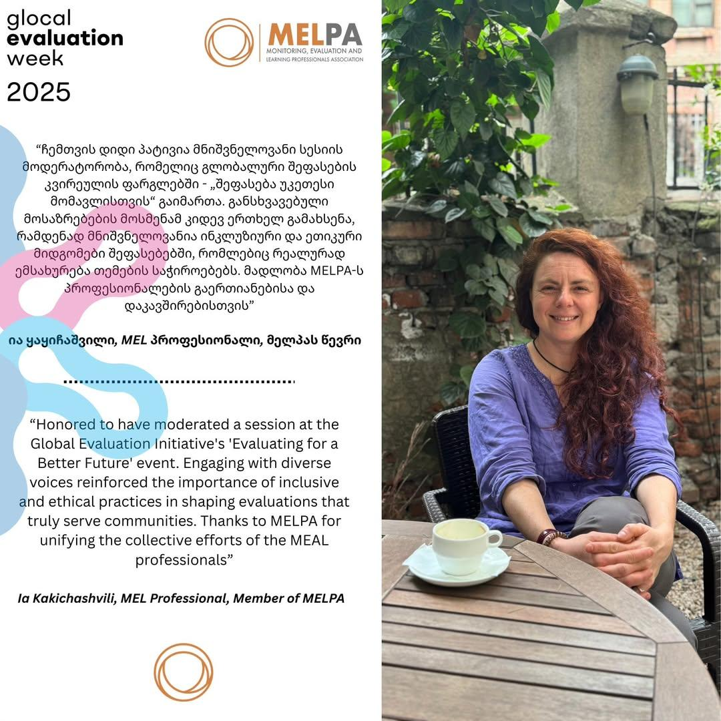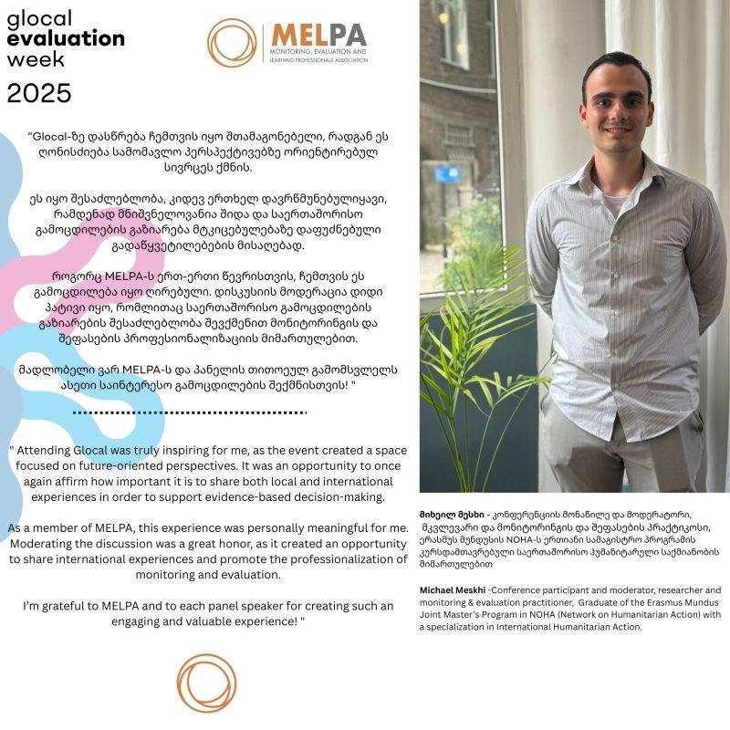

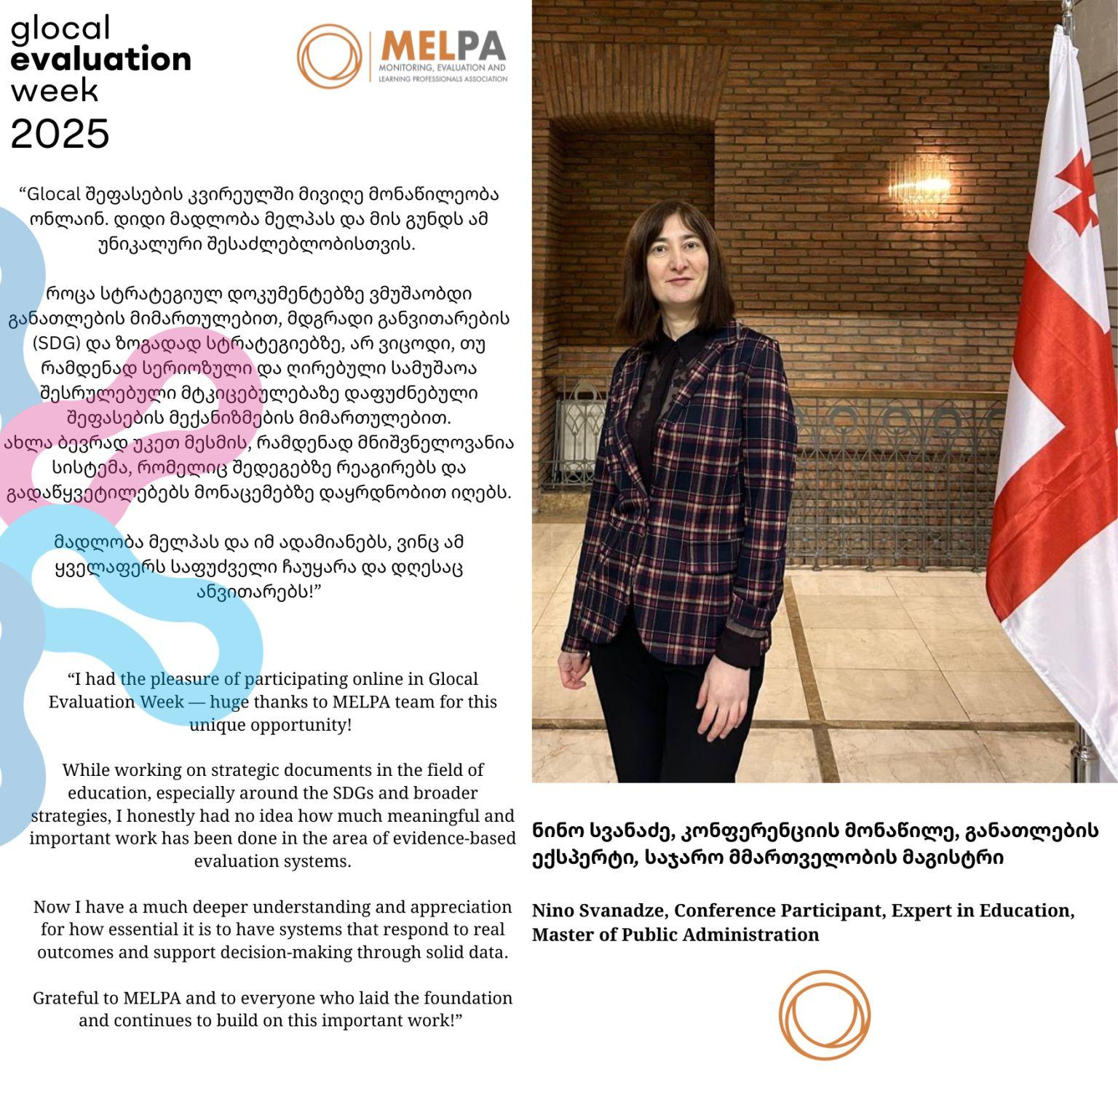

Annex III – Pictures

