SESSION REPORT
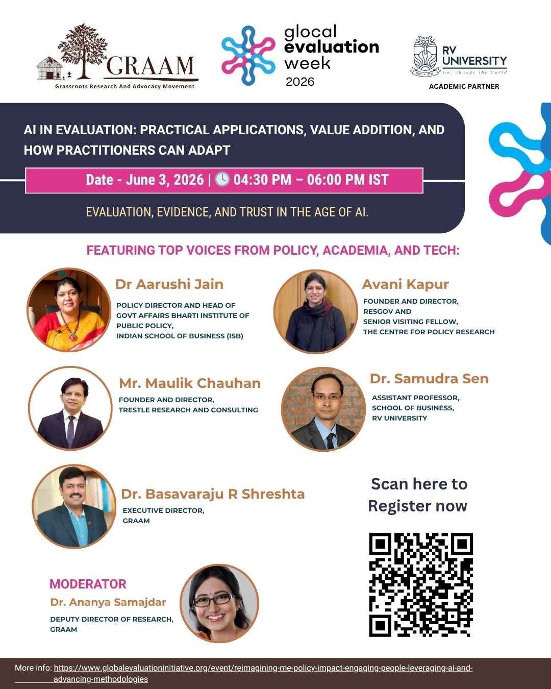

1. Introduction

The Glocal Evaluation Week is a globally convened, annual knowledge-sharing event that connects practitioners, policymakers, academics, and civil society organisations from across the world. Since its inception in 2019, the platform — convened by the Global Evaluation Initiative (GEI) and supported by CLEAR (Centers for Learning on Evaluation and Results) — has hosted thousands of events across six continents, making it one of the largest Monitoring and Evaluation (M&E) knowledge-sharing forums globally. In 2026, more than 300 sessions were held online and in person between 1st and 5th June.
GRAAM (Grassroots Research and Advocacy Movement), in partnership with RV University, organised this session as India's contribution to Glocal Evaluation Week 2026. The session was held online on 3rd June 2026, from 4:30 PM to 6:00 PM IST, under the overarching 2026 theme of 'Evaluation, Evidence, and Trust in the Age of AI', with the specific sub-theme of 'Practical Applications of AI in Evaluation'.
The session brought together five distinguished panelists — practitioners, researchers, and policymakers — to move beyond conceptual discussions on AI and ground the conversation in real-world practice, challenges, and actionable guidance for the evaluation community.
Date | 3rd June 2026 | Time | 4:30 PM – 6:00 PM IST
Mode | Online (Webinar) | Capacity | 200–250 Participants
Theme | Evaluation, Evidence, and Trust in the Age of AI | Sub-theme | Practical Applications of AI in Evaluation
Organiser | GRAAM, India | Co-Organiser | RV University

2. Session Objectives

The session was designed to achieve the following objectives:
- To present concrete, practitioner-led examples of how AI is being applied across the evaluation cycle in India and beyond.
- To critically examine where AI adds genuine value in M&E — and where its limitations and risks must be managed.
- To address the readiness of Indian public institutions and civil society organisations to responsibly adopt AI in evaluation.
- To identify the skills, ethical frameworks, and institutional capacities required for effective and responsible AI integration.
- To discuss the implications of AI for evidence quality, accountability, inclusion, and trust in the evaluation process.
- To equip evaluation practitioners — particularly those in resource-constrained and diverse contexts — with actionable steps for getting started with AI-enabled evaluation.

3. Programme Schedule

Time (IST) | Segment | Speaker / Role | Topic
4:15–4:30 PM | Pre-Session | Technical Host | Virtual lobby open | Participant join-in
4:30–4:35 PM | Welcome Address | Dr. Ananya Samajdar (Moderator) | Welcome, Introduction to Theme & Session Flow
4:35–4:45 PM | Panelist 1 | Dr. Basavaraju R. (GRAAM) | AI in Grassroots-Level Evaluation: Bridging the Gap Between Policy Intent and Ground Reality
4:45–4:55 PM | Panelist 2 | Avani Kapur (ResGov / CPR) | Using AI for Social Sector Accountability: Evidence from Social Sector Evaluations
4:55–5:05 PM | Panelist 3 | Dr. Aarushi Jain (ISB-BIPP) | Reimagining Public Programme Evaluation through AI: Readiness, Risks and Governance Challenges
5:05–5:15 PM | Panelist 4 | Mr. Maulik Chauhan (Trestle Research) | Practical AI Tools Across the Evaluation Cycle: What Works, What Doesn't, and Why
5:15–5:25 PM | Panelist 5 | Dr. Samudra Sen (RV University) | AI Tools for M&E: Scope, Potential and Limitation
5:25–5:55 PM | Q&A Round | Dr. Ananya Samajdar (Moderator) | Panel responds to audience questions | Live Interaction via Chat/Poll
5:55–6:00 PM | Key Takeaways | Dr. Ananya Samajdar (Moderator) | Summary of Actionable Insights for Evaluation Practitioners

4. About the Speakers and Moderator

Dr. Basavaraju R. Shreshta  Executive Director, GRAAM, Mysuru | A highly accomplished development professional and public policy researcher with extensive expertise in governance, programme evaluation, and public policy engagement. He leads GRAAM, a renowned think-and-act tank focused on grassroots development in India.
Avani Kapur  Founder & Director, ResGov | Senior Visiting Fellow, Centre for Policy Research (CPR) | Specializes in public finance, accountability, and local governance. Leads the Accountability Initiative focused on improving social sector service delivery in India. Her work spans evidence-based policy evaluation and governance accountability.
Dr. Aarushi Jain  Policy Director & Head – Govt. Affairs, ISB – Bharti Institute of Public Policy (BIPP) | PhD in Public Administration with over two decades of experience in education and policy sectors. Leads government affairs and policy research at one of India's premier business schools. Expertise spans AI readiness, institutional evaluation, and education policy reform.
Mr. Maulik Chauhan  Founder & MD, Trestle Research and Consulting | India Lead, SurveyCTO | Development sector professional and data systems specialist with over 15 years of experience in M&E, research, and digital transformation. Has worked with the United Nations and J-PAL South Asia, focusing on digital data collection, real-time monitoring, analytics, and AI-enabled evaluation approaches.
Dr. Samudra Sen  Assistant Professor, RV University | PhD – Public Systems, IIM Ahmedabad | Prior to joining IIM Ahmedabad, worked in a large public sector undertaking for over a decade. Research interests include public policy, productivity analysis, and education. Has published several cases, journal articles, and book chapters.
Dr. Ananya Samajdar (Moderator)  Deputy Director – Research, GRAAM | PhD in Political Science from the National University of Singapore. Has led GRAAM's research team since 2020 and handled policy research and evaluation studies for WHO, NHSRC/MoHFW, NITI Aayog, Karnataka Evaluation Authority, and UNICEF.

5. Partners and Co-Organisers

Organisation | Role | About
GRAAM – Grassroots Research and Advocacy Movement | Lead Organiser | A development research and public policy engagement initiative (think-and-act tank) based in Mysuru, India. Works across policy research, programme evaluation, community engagement, and academic collaborations with Government, Civil Society, and the Corporate sector.
RV University | Co-Organiser | A multi-disciplinary institution in Bengaluru contributing academic expertise and institutional support to the session, represented by Dr. Samudra Sen, Assistant Professor.
Global Evaluation Initiative (GEI) / CLEAR | Convening Platform | GEI convenes the global Glocal Evaluation Week and provides the platform. CLEAR (Centers for Learning on Evaluation and Results) is a GEI implementing partner that supports the event each year.

6. Speaker-wise Key Points

The following section captures the substantive contributions of each panelist, drawn from their presentations and the Q&A discussion.

Dr. Basavaraju R. Shreshta – AI in Grassroots-Level Evaluation
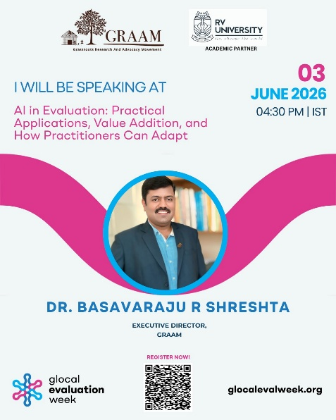
- Illustrated the 'illusion of the dashboard' using GRAAM's 2022 Forest Rights Act study in Karnataka — administrative data showed 93%+ coverage, while field verification revealed a 17% exclusion error and 91% rejection of community forest claims.
- Argued that AI must be fed bottom-up data (grievances, rejected applications, ethnographic realities) to bridge the gap between policy intent and ground reality.
- Demonstrated how NLP can analyse hundreds of pages of qualitative field notes, flag anomalies, and accelerate coding and transcription in regional languages.
- Proposed combining GIS mapping with AI pattern recognition to visually overlay rejected tribal land claims with satellite imagery, providing irrefutable evidence to authorities.
- Advocated a 'human-in-the-loop' model where NGOs and field workers mediate AI tools for communities with low digital literacy.
- Stressed that AI is not a replacement for field workers but a bridge that scales grassroots insight to the highest levels of policy making.
- Recommended that M&E organisations prioritise human capital development, establish strict ethical frameworks (such as removing identifiers before feeding data to AI), and treat AI as an amplifier — not a substitute — for participatory methods.

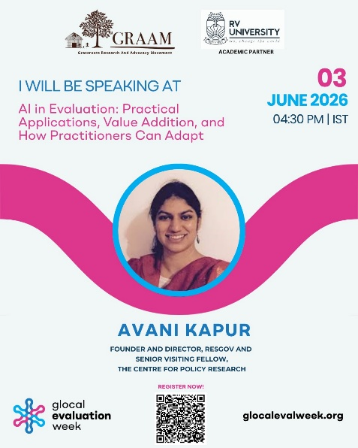
Avani Kapur – Using AI for Social Sector Accountability
- Framed the core challenge as too much data rather than too little — scattered MIS portals, budget documents, survey data, and government orders — inconsistent and difficult to compare.
- Argued that the first question should be whether AI can help organise the confusion well enough for humans to ask better questions.
- Identified three buckets of useful AI application: (1) synthesis and sense-making; (2) public finance data extraction; and (3) making data usable for frontline workers through chatbot-style interfaces.
- Cautioned that AI is weak at understanding the nuances of public finance — budget lines change names, schemes are restructured, and PDFs are scanned.
- Highlighted the risk that AI-assisted evaluations could make visible populations even more visible while making invisible populations even more invisible.
- Raised ethical and environmental concerns: advanced AI tools are expensive and inaccessible to many civil society organisations, deepening inequality.
- Recommended four principles for responsible use: transparency, verification of AI outputs against human knowledge, humility, and inclusion.

Dr. Aarushi Jain – Reimagining Public Programme Evaluation through AI
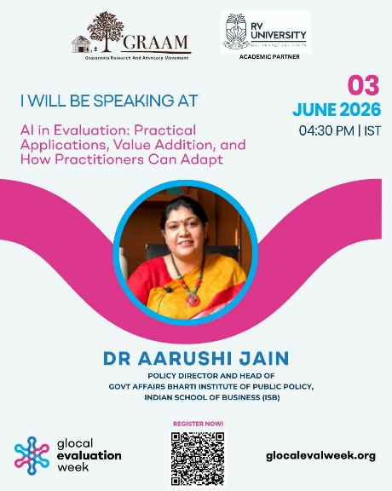
- Assessed India's AI readiness as ahead of most countries globally, citing digital public infrastructure (Aadhaar, UPI, data portals) as a strong foundation — but noted readiness is very uneven across states.
- Identified key gaps: data existing in silos across ministries, limited interoperability of administrative data, and insufficient open data ecosystems in several states.
- Highlighted the digital exclusion bias as a critical risk, drawing on Supreme Court intervention during COVID-19 vaccination registration and Aadhaar biometric exclusions.
- Cited MIT research showing 100% facial recognition accuracy for a white male versus 20% for a Black woman — underscoring how underrepresentation in training data shapes AI model accuracy.
- Proposed a three-tier audit framework: (1) coverage audits; (2) measurement audits; and (3) model audits.
- Shared a case from tribal communities in Pangi, Himachal Pradesh, where layering satellite, drone, and historic production data enabled predictive analytics for high-value crop production.
- Categorised AI use by risk level: low-risk (transcription, translation), medium-risk (scoring, anomaly flagging), and high-risk (exclusion decisions — requiring mandatory human ground-truthing).
- Introduced the TICCO prompting framework: Task, Instructions, Context, Constraints, Output.

Mr. Maulik Chauhan – Practical AI Tools Across the Evaluation Cycle
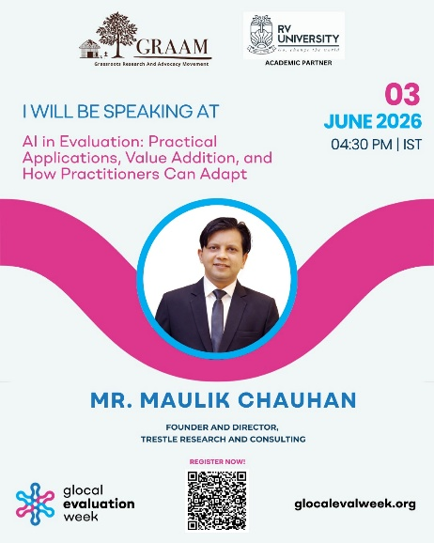
- Reframed the purpose of AI in evaluation: enabling evaluators to spend more time understanding people and less time fighting processes.
- Identified three myths: (1) AI thinks like humans; (2) AI is unbiased; and (3) AI always tells the truth.
- Demonstrated AI-assisted questionnaire refinement — transforming a closed binary question into a multi-dimensional question capturing source type, distance, and cost.
- Described how AI dramatically accelerated SurveyCTO workflow automation — tasks that previously took weeks now completed in minutes.
- Introduced real-time audio recording analysis: AI processes field audio, removes PII, and generates summaries and quality flags from day one of data collection.
- Built an internal LLM loaded with DPDP Act documents, enabling rapid compliance answers without waiting for external consultants.
- Recommended the RCTFE prompting framework (Role, Context, Task, Format, Example) and suggested asking AI to generate the prompt before generating the output.
- Coined the session's most-quoted line: 'AI will not replace evaluators — but evaluators using AI will replace evaluators who do not.'

Dr. Samudra Sen – AI Tools for M&E: Scope, Potential and Limitation
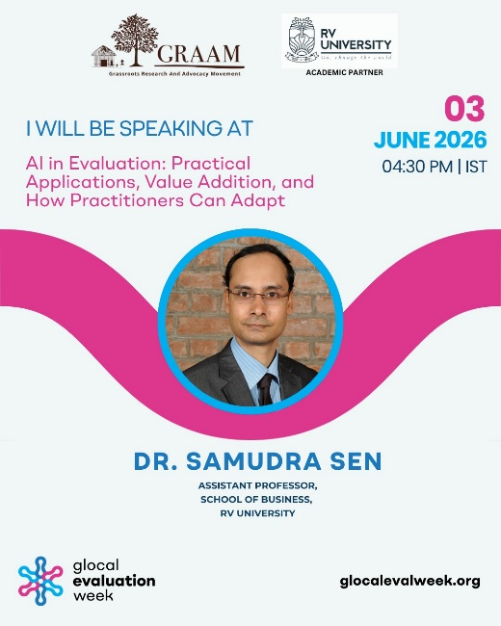
- Contextualised AI for a lay audience by pointing out that tools already in common use — ChatGPT, Siri, Google Assistant, Gemini, Alexa — are themselves AI.
- Introduced sector-specific tools: Microsoft Purview (integrated with Microsoft 365 for governance) and IBM Watson (end-to-end analytics providing a human-consultant-like interface).
- Explained emerging terminologies: GovTech, CivicTech, robo-advisors, and algorithmic government.
- Outlined AI's core advantages: speed, cost-effectiveness, scalability, 24/7 availability, and consistent performance.
- Shared international examples: SyncPass in Singapore, eCapture in the UK, legal robots in China, HazeGazer in Indonesia, and LAPOR in Indonesia.
- Highlighted AI's potential for multi-source data integration — linking siloed health, education, and departmental data using primary keys.
- Stressed limitations: ethical and legal constraints, transparency deficits, privacy concerns, hallucination, training bias, and context blindness.
- Endorsed the 'human-in-the-loop' approach as essential — including random output verification and prompt engineering as a core skill.

Participant Profile

Category | Count | % of Total
Total Participants | 223 | 100%
GENDER
Male | 114 | 51.1%
Female | 109 | 48.9%
ORGANISATION TYPE
Academic Institution | 37 | 16.6%
Non-Profit Organization | 89 | 39.9%
Private Sector Firm | 22 | 9.9%
Government | 24 | 10.8%
Evaluation Practitioners | 20 | 9.0%
Student | 14 | 6.3%
Other | 10 | 4.5%
Data Not Available | 7 | 3.1%

7. Key Takeaways

The moderator, Dr. Ananya Samajdar, synthesised the following key takeaways, reflecting the collective wisdom of all five panelists:
- Human judgment remains irreplaceable: AI cannot substitute for contextual knowledge, causal reasoning, stakeholder empathy, or the ability to read what is missing from the data.
- Human-in-the-loop is non-negotiable: AI must be supervised at every stage, with human validation mandatory for medium- and high-risk use cases.
- Bottom-up data feeding is essential: AI trained only on sanitised administrative dashboards will automate and scale existing exclusions.
- Prompt quality determines output quality: Structured prompting frameworks — RCTFE and TICCO — were recommended as practical standards for evaluation practitioners.
- Inclusion and invisible populations: AI risks making visible populations more visible and invisible populations more invisible.
- Bias auditing is essential: Coverage audits, measurement audits, and model audits should be embedded in AI-assisted evaluation design.
- Ethical safeguards are operational requirements: Removing personally identifiable information before data upload and maintaining transparency about AI use are baseline practices.
- AI's advantages are most pronounced for high-volume, repetitive, structured tasks: Transcription, coding, questionnaire review, audio summarisation, and document synthesis.
- Environmental and equity costs must be acknowledged: Energy-intensive AI systems carry carbon costs; advanced tools remain unaffordable for many civil society organisations.
- Continuous learning is imperative: Practitioners must learn, unlearn, and relearn — AI tools evolve rapidly and so must the skills to use them responsibly.

8. Conclusion

The session underscored a fundamental insight: AI is neither a magic wand nor a threat — it is a powerful amplifier of what evaluation practitioners already do. Its greatest value lies in accelerating time-intensive tasks (transcription, coding, document synthesis, anomaly detection), enabling scale without proportionally increasing cost, and making evidence more accessible to decision-makers at all levels of governance.
However, every panelist converged on a critical caution: AI is only as good as the data it is fed, the prompts it receives, and the human judgment applied to its outputs. The risk of automating and scaling existing biases and exclusions — particularly for marginalised and underrepresented populations — is real and demands proactive mitigation through bias audits, ethical frameworks, and inclusive data design.
As Avani Kapur articulated, empathy remains the irreducibly human element in evaluation — the ability to see what is missing from data, to understand power dynamics, to read body language, and to hold space for what communities do not say. The evaluation community's task is not to choose between human judgment and AI capability, but to integrate them wisely.
The session closed with a call to action for the international evaluation community: to develop shared standards for AI use in evaluation, invest in prompt engineering and AI literacy as professional competencies, and ensure that the efficiency gains of AI are shared equitably.

Annexure

Session Recordings
Zoom Cloud Recording: Click to access recording (Passcode: 5W2.ciu5)
YouTube Link: https://www.youtube.com/live/yExv6rZqLQg
List of Participants
Sl.No | First Name | Last Name | Email | City | Organisation | Job Title
1 | Bharathwaj | B | balusociologist@gmail.com | Madurai | Sadhana Foundation | Student
2 | Pooja | Reddy H | hp44298@gmail.com | Bengaluru | CHRIST UNIVERSITY | STUDENT
3 | Olga | Evdokimova | evd_oa@yahoo.com | Moscow | EVOLUTION AND PHILANTHROPY | NA
4 | Arkraj | Biswas | arkraj.biswas6@gmail.com | NA | NA | NA
5 | Mehakk | Bhardwaaj | mehakkbhardwaaj@gmail.com | NA | NA | NA
6 | Vijay | V | vincible.vijay@gmail.com | NA | NA | NA
7 | Damini | Bhoge | daminibhogedb04@gmail.com | NA | GRAAM | NA
8 | Sabna | E S | sabnae3@gmail.com | NA | GRAAM | NA
9 | Mohammed | Khizar | mohammedkhizar97@gmail.com | NA | NA | NA
10 | Bhavesh | Wadhwani | bhavesh.wadhwani13@gmail.com | NA | NIUA | NA
11 | Shaista | Khan | kshaista493@gmail.com | Kota | GRAAM | Fellow
12 | Coraima | Okfriani | coraimaokfri@gmail.com | NA | Eval Youth | NA
13 | Hrithika | Goswami | hrithika@graam.org.in | Mysuru | GRAAM | NA
14 | Debojyoti | Majumder | debojyoti@aanganindia.org | Kolkata | Aangan Trust | Senior Associate - Knowledge and Impact
15 | Palak | Sarkar | palak@massentrepreneurship.org | Bengaluru | GAME | Communications Manager
16 | Suma | Bhavana | suma.b@catalysts.org | Bangalore | Swasti | Technical Specialist - Action Research
17 | Ruchika | P | ruchika@graam.org.in | Bengaluru | GRAAM | NA
18 | Akshay | Jangam | akshay.jangam@somaiya.edu | Mumbai | K J Somaiya Institute of Management | PhD Scholar
19 | Shilpashree | Lakshmi Naryana | researchindia@buzzindia.co | Bengaluru | Buzz India Trust | Research Associate & Legal Counsel
20 | Saraswathi | Arvind | saraswathiarvind0766@gmail.com | Bengaluru | Sadhana Foundation | CEO
21 | Simi | Mishra | simi.mishra.shrm@gmail.com | New Delhi | Re:Gen Collective | Founder
22 | Antony | Stephen | stephen@mssw.in | Chennai | Madras School of Social Work | Assistant Professor
23 | Abhishek | Kumar | abhishekkumar27@lupin.com | Pune | Lupin Human Welfare & Research Foundation | Sr. Executive-MEL & MIS
24 | Dakshana | Indumathi | dakshana.indumathi@sciencespo.fr | Chennai | Student | Student
25 | Gopala | Ok | gopala@graam.org.in | Mysuru | GRAAM | Senior Associate, CPE
26 | Aakriti | Kumar | aakritikumar25@gmail.com | NA | NITI Aayog | NA
27 | Nikhilesh | T | tammananikhileshbba24@rvu.edu.in | Bengaluru | RV University | NA
28 | Shalini | Bose | bose.shalini.157@gmail.com | Kolkata | NIUA | NA
29 | Ramanjali | R | ramanjali@graam.org.in | Bangalore | GRAAM | Comms Team
30 | Susmita | Ghosh | ghoshsusmita1029@gmail.com | Kolkata | Udayan | Program Manager
31 | Gaurav | Nayak | gaurav.nayak98@gmail.com | Mangalore | Centre for Research in Schemes and Policies | Senior Associate
32 | Shubhangi | Gaikwad | ss.shubhangi@gmail.com | Pune | Consultant | NA
33 | Satarupa | Dutta | satarupa.dutta@vihaan-wms.org | NA | Vihaan | Head, Monitoring and Evaluation
34 | Debashis | Maharana | debashismaharana99@gmail.com | Bhubaneswar | SMRC | Training Coordinator
35 | Meera | Anil | meerattgl02@gmail.com | Delhi | GRAAM | Embark India Development Fellow
36 | V | J | vyjayanthi@c4ec.org | NA | C4EC | NA
37 | Jayashree | Cy | jayashree_y@toyota-kirloskar.co.in | Bengaluru | TKM | NA
38 | Priyanka | Chalwad | priyankachalwad01@gmail.com | Pune | ICMR NIV Pune | Project Research Scientist
39 | Anushree | Rai | anushree.rai1201@gmail.com | NA | GRAAM | NA
40 | Sachin | Revankar | sachin.revankar@gmail.com | Bangalore | Inspireminds | Founder
41 | Diya | Jain | djdiya5678@gmail.com | Jaipur | Mahatma Gandhi Hospital | IPD Manager
42 | Priyanka | Raikwar | priyankaraikwar213@gmail.com | Vidisha | GRAAM | Community Facilitator
43 | Soundharya | K | soundharya98ksms@gmail.com | Bengaluru | Kavintech | PA and Accountant
44 | Bhola | Nath | bholanath2001@gmail.com | Raebareli | AIIMS Raebareli | Professor and Head, CMPH
45 | Devaraj | Doddamani | devarajdoddamani261995@gmail.com | Gadag | MGRDPRU Gadag | Project Coordinator
46 | Sunayana | Sitaram | sunayana.sitaram@microsoft.com | Bangalore | Microsoft Research India | Principal Researcher
47 | Neeraj | Rana | nrana@idlo.int | NA | IDLO | NA
48 | Mahadev | Patil | mahadevklaynraop@rvu.edu.in | Bengaluru | RV University | Assistant Professor
49 | Bhanu | Nunna | bhanuprakashn@rvu.edu.in | Bengaluru | RV University | Assistant Professor
50 | Vijayakumar R | Tawker | vijayakumarrt@rvu.edu.in | Bengaluru | SoCSE, RV University | Professor of Practice
51 | Suma | M N | sumamn@rvu.edu.in | Bangalore | RV University | Assistant Professor
52 | Mobarak | Hossain | mobarak.sw@gmail.com | Kolkata | WAI | State R&D Officer
53 | Pushpa | C O | pushpaco@graam.org.in | Bengaluru | GRAAM | Research Fellow
54 | Yashwitha | T S | yashwithatsbtech24@rvu.edu.in | Bangalore | RV University | Student
55 | Monica | H A | monicaha.bcom22@rvu.edu.in | Bangalore | RV University | Student
56 | Harsha | Puranik | harshagopalkrishnapuranikbca24@rvu.edu.in | Bangalore | RV University | Student
57 | Saundarya | Shrotriya | saundaryashrotriya@gmail.com | NA | GRAAM | NA
58 | Yashas | B R | yashasbrbtech24@rvu.edu.in | NA | RV University | NA
59 | Balu | I | inchibalu@graam.org.in | Bengaluru | GRAAM | SRF
60 | Dinesh | M N | coe@rvu.edu.in | Bengaluru | RV University | Controller of Examinations
61 | Suganth | Suresh | suganthsnair@gmail.com | Bengaluru | NAVGRAAM | Associate Consultant
62 | Harikumar | Santhibhavan | harikumarvps@rvu.edu.in | Bangalore | RV University | Professor of Practice
63 | Basavaraj | Patil | basavarajp@rvu.edu.in | Bengaluru | RV University | Assistant Professor
64 | Jagadish | . | jagadishbtech24@rvu.edu.in | Bangalore | RV University | Student
65 | Christina | Carlos | christina.carlos@truhomefinance.in | Mumbai | Truhome Finance | Deputy Vice President, CSR
66 | Vijaya Bhanu | Kote | vijayabhanukote2023@gmail.com | Visakhapatnam | Dept. of Education, Andhra Pradesh | Teacher, Heutagogy Expert
67 | Nikita | Khanna | nikita@restlessdevelopment.org | Delhi | Restless Development | Head of Impact and Learning
68 | Reshma | Anil Kumar | reshma.kumar@pgp.isdm.org.in | Noida | Indian School of Development Management | NA
69 | Darshan | S | darshanpuranik@gmail.com | Delhi | The Hunger Project | NA
70 | Dipak | Talukdar | dipaktalukdar1234@gmail.com | Guwahati | DIET BAKSA | Senior Lecturer
71 | Lukas | Von Petersdorff-Campen | lukas.petersdorff@mainlevel.de | Eschborn, Germany | Mainlevel Consulting AG | NA
72 | Lloyd | Kasi | lloydkasi@gmail.com | Geneva | WHO | Evaluation Officer
73 | Pritika | Malhotra | pritika@resgov.org | NA | Foundation for Responsive Governance | NA
74 | Anita | Pena | anpenasaavedra@gmail.com | Santiago | MICARE | Investigadora
75 | Neela | Pavani | astecscscr@gmail.com | Hyderabad | Indian Railway | Deputy Chief Engineer
76 | Trang | Dao | trang.bytkcb@gmail.com | NA | My Way | NA
77 | Shilpa | Vishal | admin@graam.org.in | Mysore | GRAAM | NA
78 | Raikhan | Sabirova | rgsbrv@gmail.com | NA | Consultancy | NA
79 | Gulabi | P | gulabichowdary08@gmail.com | NA | NA | NA
80 | Mohil | Joshi | mohil.bacp@gmail.com | Lucknow | Medha | Lead Data Systems and Analytics
81 | Smriti | Dhawan | smritid.nitigov@gmail.com | NA | NITI Aayog | NA
82 | Anamika | Srivastava | anamikasrivastava@shikshalokam.org | NA | Shikshalokam | NA
83 | Gowthamghosh | Bheemireddy | gowtham.b@iihmrbangalore.edu.in | Bengaluru | Institute of Health Management Research | Assistant Professor
84 | Janardhana | D | janardhan@graam.org.in | Mysuru | GRAAM | Sr. Manager - Programme
85 | Tanzila | Naaz | nanju.nisarga@gmail.com | Mysore | Nisarga Foundation | Operations Manager
86 | Shaheed | Khan | shaheeddharthi@gmail.com | Pondicherry | Dharthi | Training, Research
87 | Siraz | Hirani | hiranisiraz@msn.com | Ahmedabad | Mahila Housing Trust (MHT) | Director Programs
88 | Shivabasayya | Mathapati | bcmrudsets@gmail.com | Bagalkote | Shri BCM Grameen Abhivruddi Samsthe | President
89 | Dr Venkatraja | B | venkatraja@sdmimd.ac.in | Mysore | SDM Institute for Management Development | Associate Professor
90 | Sharanya | J | sharanya.mgnf2021@iimu.ac.in | Hyderabad | Jupelli Consulting | Policy Consultant
91 | Kaushik | N | kaushikgaekwad@gmail.com | Tirupati | National Rail And Transportation, Ministry of Railways | Research Analyst
92 | Sudarshan | Ramaswamy | rsudarshan@jgu.edu.in | Sonipat | Jindal School Of Government And Public Policy | Dean
93 | Upma | Saxena | upma.saxena@nabard.org | Delhi | NABARD Consultancy | Vice President
94 | Dr Hari | Prasad | rewardsngo98@gmail.com | Chinthamani | REWARDS | Secretary
95 | Chinnanna | Doreswamy | cdoreswamy@gmail.com | Hunsur | Oasis Foundation | Executive Director
96 | Narayana | Hegde | nmhgadikai@gmail.com | Sirsi | Sri Sharadamba Education And Rural Development Society | Vice-President
97 | Raja | Jana | jjvraja@gmail.com | Bengaluru | Bosch India Foundation | Lead - Monitoring
98 | Foday | Turay | fturay008@yahoo.com | Abidjan | Self | NA
99 | Ragunath | Padmanabhan | howcani@gmail.com | Coimbatore | Mahat.ai | Chief Strategy Officer
100 | Lavanya | Ds | lavanya@samarthanam.org | Bengaluru | Samarthanam Trust for the Disabled | Corporate Partnerships & CSR
101 | Daker | M | dakerpa@gmail.com | Bangalore | SCMI | General Secretary
102 | Navin | Kumar | navink2003@rediffmail.com | Ranchi | NULM | Manager
103 | Mallamma | Kaiwara | seed.org2007@gmil.com | Kolar | Srusti Education and Environment Development Organisation | CEO
104 | Mohan | Surve | mohansurve@vspindia.org | Mumbai | Vikas Sahyog Pratishthan | CEO
105 | Baddi | Ramu | gssamithi@yahoo.co.in | Vishakhapatnam | Grama Swarajya Samithi | Secretary
106 | Dr Srinivasa Reddy | Mandala | ms.srinivasa@gmail.com | Hyderabad | Centre for Economic and Social Studies (CESS) | Associate Professor
107 | Rajesh | M S | rajesh@iphindia.org | Mysore | Institute of Public Health | Project Manager
108 | Harsha | Latha | harshalatha94@gmail.com | Bangalore | Samarthanam Trust for Disabled | FR
109 | Dr Srinivasa Reddy | Mandala | msrinivasareddy@cess.ac.in | Hyderabad | Centre for Economic and Social Studies | Associate Professor
110 | Venkataramana | Swamy | nrdsngo09@gmail.com | Chikkaballapur | NRDS | Secretary
111 | Venkatappa | Srinivasulu | mymastersri@gmail.com | Bangarapet | EY | Capacity Building Expert
112 | Prakash | Nayak | prakashcnayak@gmail.com | Delhi-NCR | Ecorys Netherlands BV | Public Communication Specialist
113 | Hamed | Qurbani | hamed_qurbani@yahoo.com | Kabul | FAO | NA
114 | Javeriya | Banu | javeriyab@apd-india.org | Bangalore | The Association of People with Disability | Head Governance & Compliance
115 | Hanumantha | Reddy | gramavikasatp@gmail.com | Anantapuramu | GRAMA VIKAS | President
116 | Kamruddin | Khan | kamruddin@pardadapardadi.org | Bulandshahr | Pardada Pardadi Educational Society | Head - Community Development
117 | Shivakumar | Jolad | shivakumar.jolad@flame.edu.in | Pune | FLAME University | Associate Professor
118 | Arjun | Khandelwal | arjunk@samanvayfoundation.org | Bangalore | Samanvay Research and Development Foundation | Co-founder
119 | Vijay | Rao | sgssvo@rediffmail.com | Bhinga | Shrawasti Gramodyog Sewa Sansthan | Social Work
120 | Mathew | M V | nocermathew@gmail.com | Edoor | NOCER-INDIA | Chairman
121 | Sridevi | Seetharam | desusridevi@gmail.com | Mysore District | SVYM | GB Member
122 | Ashok | Yaragatti | kidsdharwad@gmail.com | Dharwad | KIDS org | Program Executive
123 | Dr. Kakha | Nadiradze | nadiradzekakha@gmail.com | Tbilisi | Association for Farmers Rights Defense, AFRD | President
124 | Devtadeen | Pandey | bjkssshrawasti@gmail.com | Bhinga Shrawasti | Bhartiya Jan Kalyan Seva Sansthan | President
125 | Chandrakant | Ghyar Patil | jgpsshng@gmail.com | Hingoli | Jaywantrao Ghyar Patil Sevabhavi Sanstha | Founder
126 | Bhuvaneswari | Gowthaman | hodmba@dsatm.edu.in | Bengaluru | Dayananda Sagar Academy of Technology and Management | Professor and Head-MBA
127 | Morenikeji | Oke | oke.morenikeji@bouesti.edu.ng | Ikere-Ekiti | Bamidele Olumilua University of Education, Science and Technology | Lecturer/Researcher
128 | Priyank | Jindal | jindal.nidm@gmail.com | NA | Vassar Labs | Knowledge and Partnership
129 | Anjali | Mishra | mishanj708@gmail.com | Biratnagar | BMCTH | NA
130 | Abdul | Kabir | abdulkabir0006@gmail.com | Noida | BAL BHARTI Academy | Project
131 | Chitra | Shah | satyaspecialschooldirector@gmail.com | Puducherry | Satya Special School | Director
132 | Kowshika | R | kowshikaramakrishnan@gmail.com | NA | Nakkubetta Foundation | NA
133 | Pramod | Sawant | pramodvsawant81@gmail.com | Mumbai | Annapurna Sewabhavi Sanstha | President
134 | Balakrishnan | K | vgbala3843@gmail.com | Tiruchirappalli | Mother Therasa Social Service and Development Society | Director
135 | M | Vaz | mvaz@ijm.org | NA | IJM | NA
136 | Srivaramangai | Sankaranarayanan | mangai_india@yahoo.co.in | Chennai | INDIA NGO | Project Director
137 | Neeraj | Trivedi | neerajtrivedi@pratham.org | NA | Pratham Education Foundation | NA
138 | Mohanapriya | B | mohanapriya20b@gmail.com | Tiruvannamalai | Sarvam Trust | Admin
139 | Retta | Gudisa | rettagudisa16@gmail.com | Addis Ababa | World Vision International | MEAL Director
140 | Yadagiri | Manje | capatsngo@gmail.com | NA | CAPATS NGO | Secretary & CEO
141 | Lokesh | Kumar | lokeshdjb@gmail.com | Alipur | Delhi Jal Board | Chemist
142 | Shekhar | Prasad | pradanfoundation@gmail.com | Chatra | PRADAN Foundation | Secretary
143 | Nasir | Ayub | nasir.r.ayub@gmail.com | Islamabad | Spectra Engineering Solutions (Pvt.) Ltd | CEO
144 | Keerthikumar | Janakiraman | keerthi@hotmail.co.in | Puducherry | Empowerise India Foundation | Director
145 | Nisarga | M N | nisargaintern@iphindia.org | Bengaluru | IPH | Intern
146 | Madhuri | Agarwal | madhuri.deveco@gmail.com | London | Oxford University | Senior Education Specialist
147 | Jayakumar | K | jayakumar@svym.org.in | Mysuru | SVYM | Project Director - School Education Program
148 | Julia | Engelhardt | julia.engelhardt@wto.org | Geneva | WTO | Evaluation Specialist
149 | Deepak | Jain | djain0315@gmail.com | New Delhi | Vijayash Foundation | Founder
150 | Darshan | R S | darshansuri13@gmail.com | Kollegal | CRISP | Fellow
151 | Praveen Dani | Victor | pdv@anbusuzhulagu.com | Madurai | Anbu Suzh Ulagu Foundation | CEO
152 | Rupchand | Dakhane | gramarogya@rediffmail.com | Kurkheda | Gram Arogya Ghati | Secretary
153 | Ananya | Samajdar | ananya@graam.org.in | Bangalore | GRAAM | Deputy Director Research
154 | Doha | Abdelhamid | abdelhamiddoha@yahoo.com | Cairo | NIGSD Mped | Sr Advisor to CEO
155 | Nitesh | Pathak | pnitesh2020@gmail.com | Lucknow | Rozana | Senior Manager
156 | Ahmed | Youssef | ayoussef@unfpa.org | Fayoum | UNFPA Egypt CO. | NA
157 | Balu | I | baluinidm@gmail.com | NA | GRAAM | RF
158 | Vasundhara | Vaidya | aar10me@gmail.com | Bangalore | BITS Design School | Student
159 | Syed | Imran | mehdaviaswtt@gmail.com | Channapatna | Mehdavia Social Welfare Trust | Social Activities
160 | Anjana | Devi | banjanadv2000@gmail.com | Vijayawada | Independent | Researcher
161 | Bachchu | Jha | bachchujha55@gmail.com | Sitamarhi, Bihar | R Jha College | Head of Mathematics Department
162 | Ambadas | Kanade | renukabsbs7@gmail.com | Gangapur | Renuka Bahudheshiya Sevabhavi Sanstha | Secretary
163 | Raghavendra | M | ragavendra@graam.org.in | Bengaluru | GRAAM | Admin
164 | Rishikha | K | rishikhakbba24@rvu.edu.in | Bangalore | RV University | Student
165 | B | Muniyandi | tamilbosemuniyandi@gmail.com | Madurai | Annai Fathima College of Arts and Science | Head - Dept. of Tamil, NSS & YRC
166 | Ravi | C S | ravics@graam.org.in | Mysore | GRAAM | Coordinator
167 | Shivaprasad | Nayak | sprasadhn1@gmail.com | Bangalore | Gogte Institute of Technology | Professor
168 | Avani | Kapur | avani@resgov.org | New Delhi | ResGov | NA
169 | Maulik | Chauhan | maulik@trestle.co.in | Ahmedabad | Trestle Research and Consulting | Director
170 | Akshata | Tarase | akshatatarase1995@gmail.com | Bangalore | Diya Ghar | Donor Reporting Consultant
171 | Eshaa | Setty | eshaa.setty@flame.edu.in | Bengaluru | GRAAM | Intern
172 | Dr. Samudra | Sen | samudras@rvu.edu.in | Bangalore | RV University | Assistant Professor
173 | Aarushi | Jain | aarushi_jain@isb.edu | Chandigarh | Indian School of Business | Director
174 | Ridhi | Tirkey | ridhitirkey@gmail.com | NA | NA | NA
175 | Srinivas | Prasad | pspmysore08@gmail.com | NA | University of Mysore | Liaison Officer
176 | Anirban | Das | anirban@graam.org.in | Bangalore | GRAAM | Manager
177 | Nishitha | Ramachandra | nishitharamachandrabba25@rvu.edu.in | Bangalore | RVU | Student
178 | Shaun | Steven | shaun@navgraam.in | NA | NAVGRAAM | NA
179 | Susmita | Ghosh | program.manager@udayan-kolkata.in | Kolkata | Udayan | Manager
180 | Bidhu | Khanna | bidhukhanna@gmail.com | NA | GRAAM | Fellow
181 | Snehala | G P | snehalagpbba25@rvu.edu.in | Bangalore | RV University | Student
182 | Kimberley | Monteiro | kimberley.j.monteiro@gmail.com | Delhi | NA | Fellow
183 | Indupalli | Kavitha | kavithahindi1983@gmail.com | Yeleswaram | APSWREIS Yeleswaram | TGT Hindi
184 | Raghu | Gowda | rgowda685@gmail.com | Bangalore | GRAAM | Admin
185 | Dr Basavaraju | Shreshta | basavaraju@graam.org.in | Mysore | Grassroots Research And Advocacy Movement | NA
186 | Vishnu | P | vishnup6265@gmail.com | Bengaluru | GRAAM | Fellow
187 | Prof Dr Shivalingaiah | Mallappa | shivalingaiahm1970@gmail.com | Tumkur | Suvarna Karnataka Integrated Rural Development Society | Founder Secretary and MD
188 | Pavan | B | pavan@graam.org.in | NA | GRAAM | NA
189 | Ramya | Chintala | ramyac1904@gmail.com | NA | GRAAM | NA
190 | Sancheeta | Ghosh | sanchitaiips@gmail.com | NA | Swaniti | Lead, MEL
191 | Udaya | Ms | udayms.kavintech@gmail.com | Bengaluru | Kavintech Corporation | Business Executive
192 | Rashmita | Sharma | rashmitasharma256@gmail.com | Tezpur | Indian School of Business | Research Fellow
193 | Prakyath | Graam | rtrprakyath@gmail.com | Bangalore | GRAAM | Fellow
194 | Purushothaman | Shanmugam | purushothaman@rvu.edu.in | Bangalore | School of Design & Innovation, RV University | Assistant Professor
195 | Vijay | V | invivel@gmail.com | NA | GRAAM | Fellow
196 | M | Mthr | masha_28@rediffmail.com | NA | Independent Researcher | Researcher
197 | Deepak Prabhu | Matti | deepakprabhu.matti@cognizant.com | Bangalore | Cognizant Foundation | CEO
198 | Samriti | Maharjan | samriti813@gmail.com | Patan | EvalYouth Nepal | NA
199 | Katharina | Kreutz | katharina.kreutz@welthungerhilfe.de | NA | WHH | NA
200 | Adriana | De Queiroz | adequeiroz70@gmail.com | Rio De Janeiro | Criteria Solucoes | Manager and Evaluation Specialist
201 | M | Gaupale | hatwp76@gmail.com | Tumsar | ShikshaLokam | Program Associate
202 | Sahnaa | R | sahana@graam.org.in | Mysore | GRAAM | Data Management and Reporting
203 | Rimsha | Masroor | masroorrimsha0@gmail.com | Ahmedabad | Trestle Research | Research Associate
204 | Sankaranarayanan | A S | info@nmctngo.org | Coimbatore | NATIVE MEDICARE CHARITABLE TRUST | Director
205 | Vasantha Lakshmi | B R | vasanthalakshmibr@rvu.edu.in | Bangalore | RV University | Deputy Controller of Exam
206 | Yi | Win | yi2win@yahoo.co.uk | NA | R E Searby Ltd | NA
207 | Gowri | Prasad | gowri.prasad97@gmail.com | Bengaluru | GRAAM | Policy Fellow
208 | Pragya | Sharma | sharmapragya0007@gmail.com | Raisen | GRAAM | NA
209 | Amu | A | dramrita.and@gmail.com | New Delhi | PCC | Specialist
210 | Riya | Mohan | riyamhn02@gmail.com | New Delhi | GRAAM / NITI Aayog | Fellow
211 | Divya Sudha | Velimala | divyasudhavelimala@gmail.com | NA | Student | NA
212 | Sreelatha | H S | lathasrinivas886@gmail.com | NA | IIT KGP | NA
213 | Shalvi | Suman | shalvirsuman@gmail.com | Delhi | National CAMPA | Research Fellow
214 | Manjunath | Reddy V | manju1vr2004@gmail.com | Bangarpet | NA | NA
215 | Sreelatha | H S | sreelatha.hs25@kgpian.iitkgp.ac.in | NA | IIT Kharagpur | NA
216 | Naived | Eapen | naived.eapen@christuniversity.in | Bangalore | Christ University | Coordinator, Centre for Artificial Intelligence
217 | Prabhanshu | Singh | prabhanshu.singh@theeducationalliance.org | New Delhi | The Education Alliance | Program Lead
218 | Diana | Jara Colquichagua | diana.jara@ucr.ac.cr | NA | UCR | NA
219 | Manuela | Marolla | manuela.marolla@gmail.com | NA | / | NA
220 | Matthew | Van Geest | mvangeest@foodgrainsbank.ca | Winnipeg | Canadian Foodgrains Bank | NA
221 | Sharon | Ndandula | sharon.ndandula@gmail.com | NA | Self | NA
222 | Shanta | Kumar | shanta.iitb@gmail.com | Noida | Navodaya Mission Trust | Chairperson
223 | Saklesh S | Nagouda | saklesh.s.nagouda@christuniversity.in | Bangalore | CHRIST UNIVERSITY, BANGALORE | Associate Professor

Photos

